Created 04/24/2018, updated 04/17/2020

member handbook
For co-working members at the Innovation Center
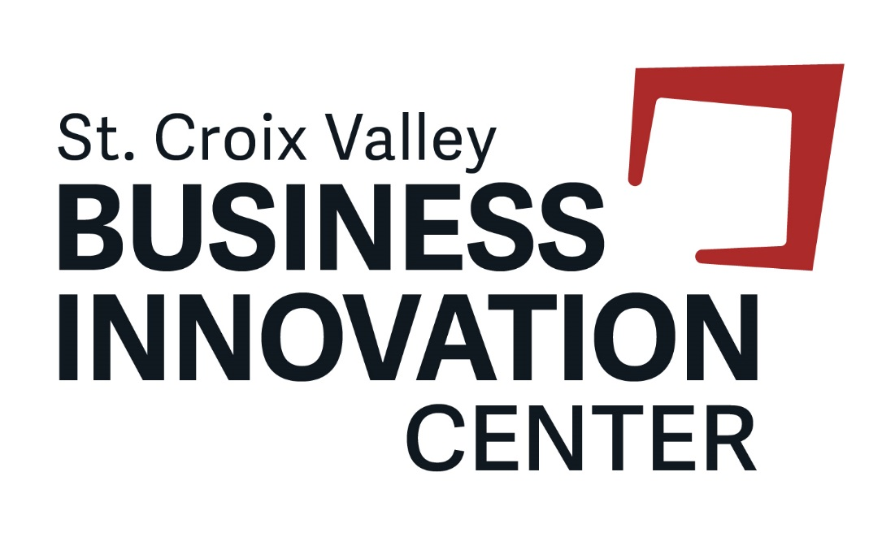
Table of Contents
Overview 2
Contacts 2
Management Assistance 2
Administrative Assistance 3
Access to Premises 3
Shared-use Equipment 4
Internet Access and Use 5
Care of Premises 5
Payment 6
Agreement 6

Overview

Welcome to the St. Croix Valley Business Innovation Center’s Co-Working Membership. As a member of the Center, you will have access Co-working space, networking activities and programming, meeting room space and business consulting offered by the Small Business Development Center.

Location: The St. Croix Valley Business Innovation Center is located in the Sterling Ponds Corporate Park in River Falls, WI. The Innovation Center includes approximately 30,000 square feet of leasable space with adjacent parking areas. The building is fully equipped with a sprinkler and fire alarm system tied directly to the fire department.

Contacts

Title Staff Name Email Phone
Interim Director Sheri Marnell Sheri.Marnell@uwrf.edu 715-425-4288

For medical emergencies, call 9-1-1. For non-emergency issues or issues during normal working hours please call the Receptionist at 715-425-3066. For serious issues outside of business hours, call the Center Director at 651-323-8002.

1091 Sutherland Avenue
River Falls, WI 54022
www.StCroixInnovation.org
715-425-3066

Management Assistance

Center Staff – The Innovation Center has staff members which are employees of the University of Wisconsin-River Falls. A management committee oversees operations of the facility and programming and reports to the Board of Directors for the River Falls Economic Development Corporation, the organization that owns the facility. The Director manages facility operations, the Incubation Program, lease agreements, member agreements and any other items related to tenancy. The Coordinator and Administrative Assistant assist the Director with facility operations, marketing and programming and are also available to assist tenants and members with needs.

Small Business Development Center – The Small Business Development Center (SBDC) at UW-River Falls is located in the St. Croix Valley Business Innovation Center. The SBDC provides no-cost consulting for businesses located in Polk, St. Croix and Pierce counties in addition to programming that includes an Entrepreneurial Training Program. To request consulting, visit the SBDC website: https://www.uwrf.edu/CBE/Centers/SmallBusinessDevelopmentCenter/.

Training/Programming/Networking – Watch for notifications regarding training, workshops, networking events and other opportunities to learn and connect with the entrepreneurial community. For customized training opportunities, contact the Center Director to discuss options.

Resource Partners – Numerous resource partners work with small businesses to help them grow. Below is a selection of resource partners in the region. For more information, contact the Center Director.

- SCORE
- WI Economic Development Corporation
- Momentum West
- County and municipality Economic Development Corporations
- UW-Stout Discovery Center (Center for Innovation and Development)
- WiSys
- IdeaFund of LaCrosse
- Regional Business Fund
- UW-River Falls

Administrative Assistance

Receptionist – The Business Innovation Center will have a Receptionist who will direct guests to the proper location, accept mail, oversee access to copying, assist with technology and answer the phone for the main line to the Business Innovation Center.

Mail & Shipping – Mail service is not included for co-working members, however, you may coordinate shipping of mail and packages with the receptionist. UPS & FedEx deliver to the receptionist. You may arrange for pickup of outgoing packages by contacting the carrier. All outgoing packages must be brought to the receptionist desk, the designated pickup site. Carrier info: UPS – www.ups.com; FedEx www.fedex.com.

Access to Premises

Common Areas – All members shall have a nonexclusive right to access to such common areas within the facility. The Co-working area on the East end of the facility includes 14 non-designated open workspace seats. Members are allowed to utilize any open seat. Use of the workstations or cubicles adjacent to the Co-working area are not included in the monthly membership rate. If interested in leasing a workstation, contact the Center Director to apply to the Incubation Program. Shared spaces include:
- Kitchen/Break area
- Reception area
- Co-working areas
- Hallways
- Restrooms

The sidewalks, passages, exits, entrances and stairways of the Premises shall not be obstructed by any of the Members or used by them for any purpose other than for ingress to and egress from their respective location.

Key Cards - The Innovation Center is responsible for keying all spaces and will provide Members one key card. The key card must be turned in to the receptionist upon cancellation of Membership.
If key card is lost, the member will be charged $25 for a replacement card. Each member will have access only to doors which are necessary and include the exterior front entrance doors, conference room door and entrance to co-working area. Key cards shall not be given to anyone other than registered member for access. Guests must be accompanied by a registered member of the business and shall not be allowed free access to any part of the facility unless special arrangements are made.

Security - The Innovation Center assumes no responsibility for the security of the property or the personal property of the members or invitees. No sleeping or overnight stays are allowed in the facility. The facility is accessible 24/7, however, individuals in the facility after hours must be actively engaged in business functions. There are security cameras monitoring the facility 24/7.

Parking: Parking is available for Members and guests. The Innovation Center may, from time to time, assign parking spaces and may require specific areas to be designated for Incubator Client’s customers, guests or employees. Overnight parking is not allowed unless work is being completed on site. Parking is not allowed in the dock area (along the North side of the building), this space is reserved for delivery vehicles only.

Conference room –5 hours of access per month is available at no additional charge. This room is available to be used for activities directly related to your business. This room is available on a first come first serve basis. Reservations are required to be entered into the required software program.

Training room – The training room is available to reserve for larger events or meetings at current rate. Reservations can be requested through the specified software program.

Shared-use Equipment

The following equipment is available to Members at no cost, unless otherwise indicated:

Display screen – A display screen and HDMI cord are available for use in the Conference room. Bring your own device to connect to the screen.

Projector screen – A large projection screen and teaching station is available for use in the training room. Bring your own device to connect to the screen.

Conference phone – A conference phone is available for use in the conference room. Guests may dial-in to the phone at 715-425-3049.

Vacuum cleaner - A vacuum cleaner is available for use if needed. Check out the vacuum cleaner from the receptionist and return upon completion.

Storage Cabinets – A locked storage cabinet is available for use by Members at no additional charge. To reserve a cabinet, contact the receptionist to check out a key. Key must be returned upon cancellation of membership or additional re-keying charges will apply. Personal items must not be left in the shared spaces when the member is not on the premises. Items left on the premises will be held for 5 days and then becomes property of the Center.

Internet Access and Use

Access to non-registered, unsecured guest Wi-Fi network is included in the Membership fee. Wireless connection should only be used for purposes related to business activities. To access Wi-Fi, connect to the network UWRF-Welcome and navigate to www.uwrf.edu to verify access. Dedicated internet may not be installed in the co-working space; please inquire with Center staff about use of the Flex space if dedicated internet is required.

Care of Premises

Smoking is not permitted inside the building or on the property.

In an effort to maintain a professional environment, pets and children are not permitted inside the facility. If you have a special need, please discuss with center staff. Additionally, appropriate attire and self-hygiene are expected at all times.

Maintenance Responsibilities: All general repairs and maintenance will be the responsibility of the St. Croix Valley Business Innovation Center. All repair or maintenance requests shall be reported to the receptionist.

Members and guests must observe strict care and caution that all water faucets, water apparatuses and utilities are shut off before exiting the premises and will be financially responsible should waste or damage occur to the facility through oversight. The toilet stalls, toilets, wash bowls and other apparatus shall not be used for any purpose other than that for which they were constructed; no foreign substance of any kind shall be disposed of in the toilet or down the drain. The expense of any breakage, stoppage or damage resulting from violation of this rule shall be borne by the Member who, or whose employees, agents or invitees, shall have caused it.

Repairs & Alterations: The Member shall not perform any act or carry on any practices that may injure the Premises or be a nuisance or a menace to other tenants, members or guests of the facility. Any repairs beyond reasonable wear and tear will be charged back to the client.

Janitorial Services: The Innovation Center provides janitorial services including vacuuming and trash removal for private office spaces, common areas, and the training and conference rooms. Members are required to clean up after themselves in all shared spaces. Members shall place trash generated from normal business use in appropriate receptacles on the Property. Dumpsters are located on the north side of the building. Items from other locations or in violation of local codes (including computers and other electronics) cannot be accepted. Any hazardous materials, including but not limited to items such as paint must be disposed of in accordance with local ordinances.

Signage: The Innovation Center shall provide uniform signage for the facility. No other signage is permitted without express written consent of the Innovation Center Director. Please provide a written proposal to the Innovation Center Director.

Kitchen and Break Area: Food and beverages are available for purchase in the Kitchen/Break Area. Members are responsible for cleaning up all messes in the Kitchen/Break Area including prompt removal of any items stored in the refrigerator or freezer.

Quiet Enjoyment: All Members, guests and tenants have the right to peaceably and quietly have, hold, and enjoy the Premises for the duration of the Lease Agreement. No Member is permitted to disturb the quiet enjoyment of another outside the normal course of business. Loud music, loud phone or mobile device alerts and raucous behavior are examples of such.

Complaints: Please submit complaints to the Director by emailing contact@stcroixinnovation.org or by calling 715-425-4775. Any complaints will be investigated and addressed in a timely manner.

Payment

Monthly memberships begin the day payment is received by the St. Croix Valley Business Innovation Center. You have the opportunity to enroll in the auto-renewal program and reminders will be sent out on a monthly basis. Payments not received by the next payment due date will result in membership termination and keycard deactivation. No refunds will be given for partial months. An invoice will be sent electronically each month. Payment can be made via credit card or check.

Agreement

The St. Croix Valley Innovation Center and Member hereby agree that the preceding statements are for the benefit of each Incubator client and the operation of the facility. The Innovation Center is authorized to create these agreements and may change them at the Innovation Center’s discretion. The Innovation Center reserves the right to make such other reasonable rules and regulations as in its judgment and may from time to time be needed for the safety, care and cleanliness of the Premises, and for the preservation of good order therein. The Innovation Center may waive any one or more of these Rules and Regulations for the benefit of any particular Innovation Center client, guest or member. Non-compliance with these Rules and Regulations may result in discontinuation of co-working membership. These Rules and Regulations are in addition to and shall not be construed to in any way modify, alter or amend, in whole or in part, the terms, covenants, agreements and conditions of any lease of the Premises.

Signature: __________________________________ Date:____________

Printed Name: _______________________________

Company: __________________________________

